Git Cheat Sheet

Cloning a Repository
To download a repository's files from off GitHub, locate the “HTTP” link on the main page:

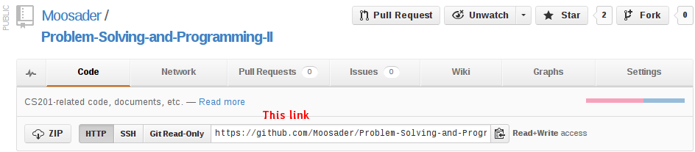
Highlight and Copy that link.

In Windows Explorer, navigate to a folder where you're storing repositories.
In empty space, Shift + Right Click, and then click on Open command window here.

At the command window, enter:
git clone [url]

You can right-click in the DOS prompt and click paste.

The files from the repository will be downloaded to that directory.

Committing your Changes
When you want to commit a change to a file to the GitHub server, you need to use the add command.
git add [filenames]
You can also use:
git add *
which will add all files in the current directory and sub-directories. Sometimes, you may not want to include project files in your repository, but for now go ahead and use * when adding your files.

To commit the changes, use:
git commit -m "Information about my commit"
You can also use just git commit and Windows will open up Notepad for you to enter a commit message. Write a message, save, and close notepad.

Sync with the Server
To push your changes up to the server, type in:
git push -u origin master
Your changes will be visible on the website.

If you have your repository on more than one computer and you have pushed new code in location A, you can update the code from location B by typing:
git pull

